SHREYA CONTACT APP SCREENSHOTS:

I used react-native,stylesheet and sqlite for storage. Made in React-Native CLI, installed android studio used Virtual emulator and stack navigator to navigate on button clicks.

List of Contacts Page:

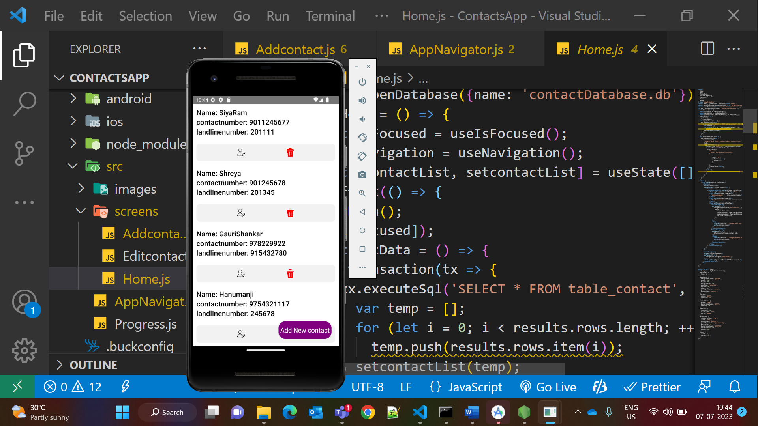

Add Contact page:

Adding new contact of ‘Roshan’

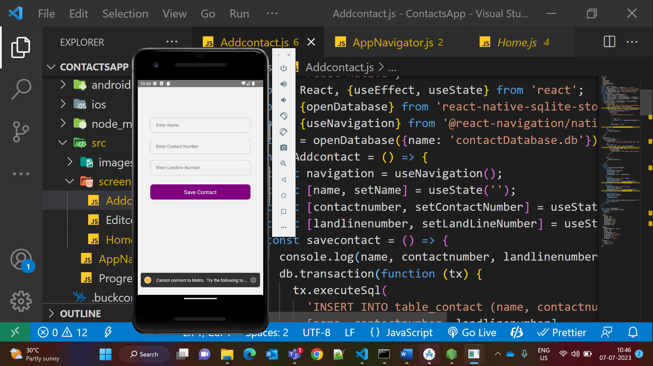

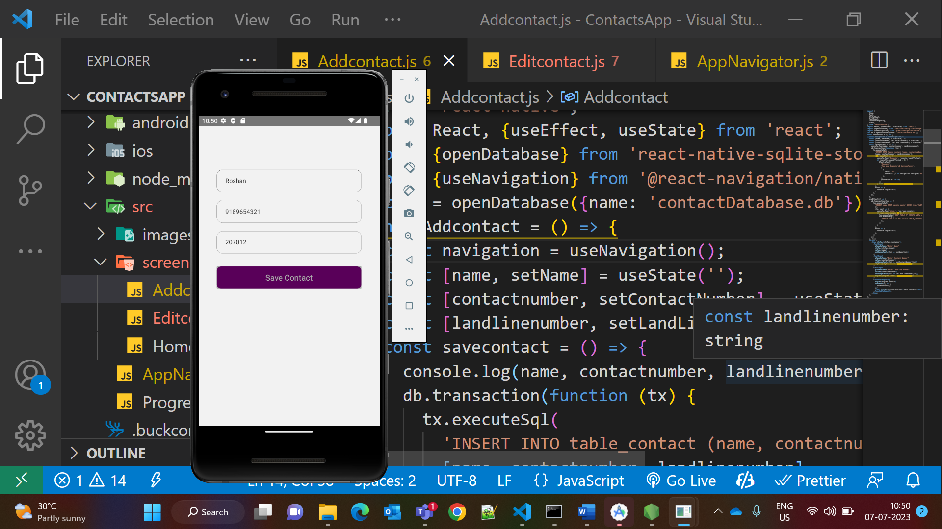

Edit Contact Page:

Editing Shreya contact ,Name from ‘Shreya’ to ‘Shreya Dixit’

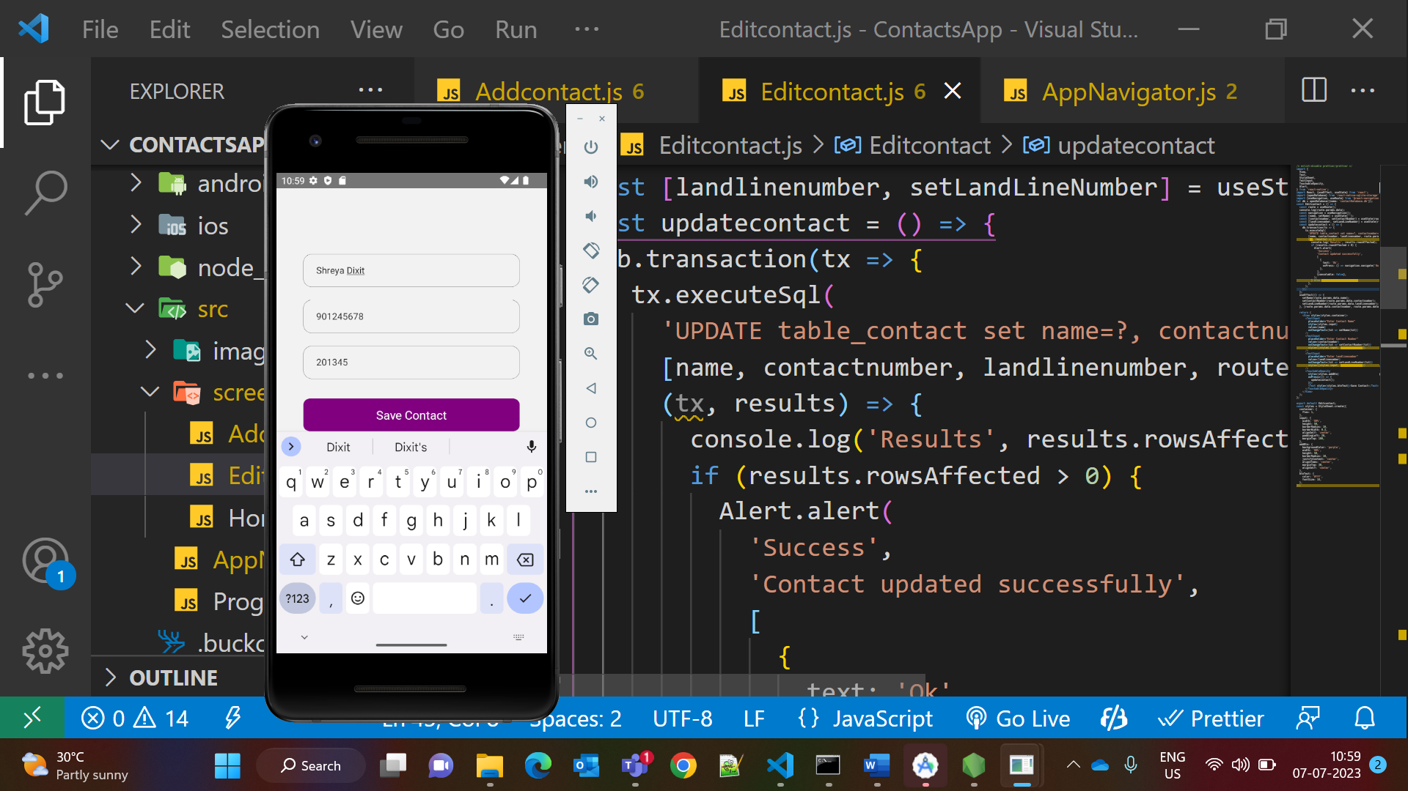

Delete Contact Page:

Deleting Contact of ‘Roshan’

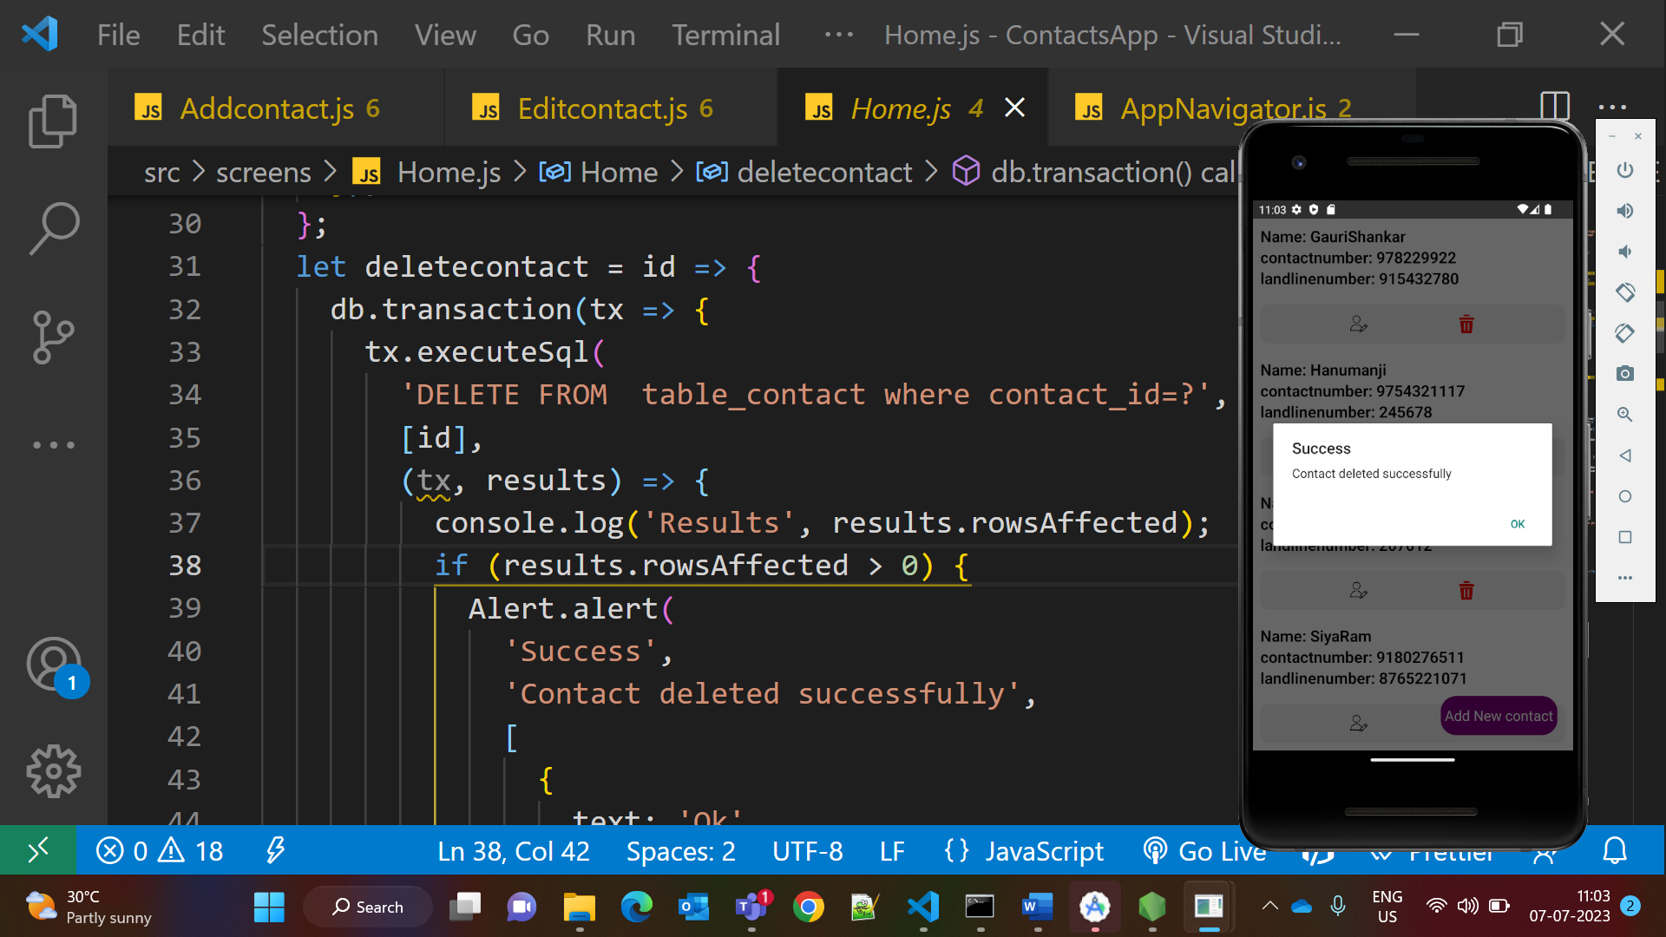

Now there will be no contact like ‘Roshan’

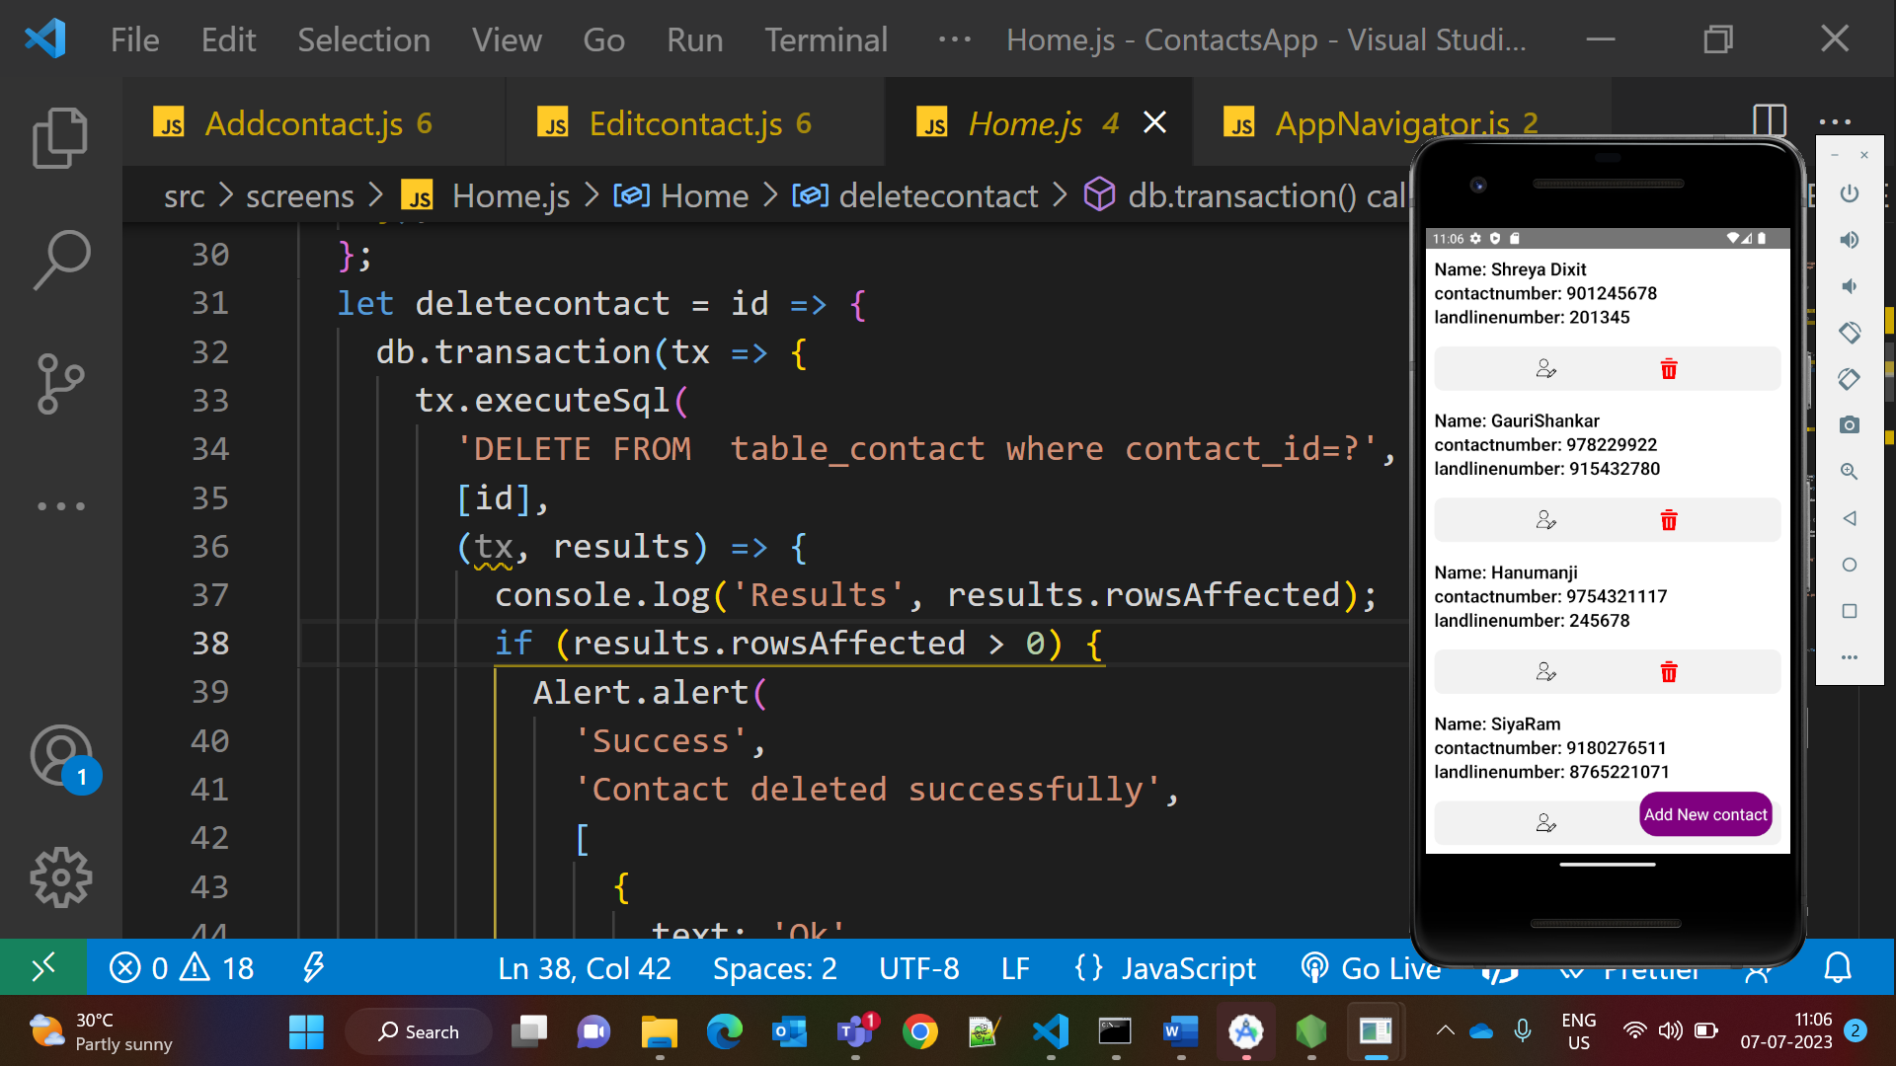

--------------------------------------End of File-------------------------------------------------------------------------